1 August 2014

Requests For Qualifications in concern of Professional Engineering Services for Hudson Boulevard – Chatlin Lake Canal Bridge Replacement

The City of Alexandria is seeking professional services for the development of plans and specifications for the replacement of an existing three-span concrete deck, wooden pile structure located on Hudson Boulevard at the Chatlin Lake Canal crossing.

Questions:
Questions regarding this request shall be directed to the City of Alexandria (CoA) at:

Eric Duck, P.E.
Assistant City Engineer
(318) 473-1170
eric.duck@cityofalex.com

Statements of Qualification:
Four (4) hardcopy statements of qualification and one electronic copy must be received by the CoA by 4:00 p.m. on Wednesday, 1 October 2014. All copies of the statements must be plainly indentified as “Hudson Boulevard – Chatlin Lake Canal Bridge Replacement” and delivered or mailed to:

Michael J. Wilkinson, P.E.
625 Murray Street, 2nd Floor
Alexandria, LA 71301

Late Submissions:
Proposals received after 4:00 p.m. on Wednesday, 1 October 2014 will not be considered and returned unopened.
Section 1: Introduction
  - Intent
The City of Alexandria (CoA) seeks to contract for professional design services for the purposes of developing plans and specifications for the purposes of constructing a new crossing on Hudson Boulevard for Hynson Bayou.

Respondents and their agents are strictly prohibited from lobbying staff and officials of the City at any time in the application and selection process. Failure to comply with this clause shall be grounds for rejections of their submittal.

  - Request for Qualifications Timeline
RFQ Release Date | 1 August 2014
Submittal of Questions Due | 1 September 2014
Question Responses Posted | 12 September 2014
Statement Submission Deadline | 1 October 2014

All firms intending to submit qualifications are strongly encouraged to indicate their intent to respond to the CoA by sending an email with the subject line “Hudson Boulevard – Chatlin Lake Canal Bridge Replacement - Submittal Intent” to Eric Duck, eric.duck@cityofalex.com. The CoA will provide all firms that have indicated their intent to respond in this manner with any addendums or modifications to the RFQ directly.

  - Questions and Addendums/Modifications
Answers to questions received in writing at the above email address by 1 September 2014 will be compiled and provided via email to all firms that have indicated intent to submit by 12 September 2014. Additionally, addendums/modifications to the RFQ will be emailed to the firms that have indicated intent to submit qualifications.

Section 2: Scope of Work
2.1 Background and Project Goals

Hudson Boulevard is thoroughly traveled roadway located within the boundaries and under the jurisdiction of the City of Alexandria. This roadway provides an east-west corridor from LA 1208-1 (Eddie Williams Boulevard) to LA 1. In the course of its alignment, this roadway crosses Chatlin Lake Canal, a major drainage feature located within the City of Alexandria. The existing structure crossing Chatlin Lake Canal is a composite structure consisting of a pre-cast concrete deck and cast-in-place caps with a wooden pile substructure constructed in 1979. The Chatlin Lake Canal is within the jurisdiction of the Red River, Atchafalaya and Bayou Boeuf Levee and Drainage District.

Recent inspections of this structure have found decayed piling on both of the intermediate bents. In light of these deficiencies, the city has decided to invest in its infrastructure by replacing this structure in its entirety.
The city anticipates letting this project for construction during its next Fiscal Year beginning May 1, 2015. Therefore, plans, specifications and bid package shall be completed so as to accommodate construction thereafter.

2.2 Anticipated Scope of Work
Work shall consist of Basic Design services to prepare construction plans and specifications (in accordance with CoA standards) in the following steps: 1) Program Completion, 2) Preliminary Plans, 3) Plan-In-Hand, and 4) Final Plans. Other Basic Services shall include bidding the project for construction and construction administration.

Additional Services may consist of Environmental Assessment/Permitting, design survey, geotechnical investigation and project inspection services. These items will be addressed in more detail during contract negotiations.

2.3 Deliverables
Expected deliverables shall consist of plans, specifications and bid package for the purposes of constructing the improvements to the Hudson Boulevard – Chatlin Lake Canal Bridge Replacement in accordance with the Scope of Work listed above. These milestones will be established with the selected consultant during contract negotiations.

Section 3: Rules Governing Competition
3.1 Addenda, Rejection and Cancellation
The CoA reserves the right to revise any part of the RFQ by issuing an addendum to the RFQ at any time prior to the submission deadline. Issuance of this RFQ in no way constitutes a commitment by the CoA to award a contract. The CoA reserves the right to accept or reject, in whole or part, all proposals submitted and/or cancel this announcement if it is determined to be in the best interest of the CoA. All materials submitted in this response become the property of the CoA and selection or rejection of a proposal does not affect this right. The CoA also reserves the right, at its sole discretion, to waive administrative informalities contained in the RFQ. The CoA will email modifications when released to each respondent intending to submit a statement. Respondents and their agents are strictly prohibited from lobbying staff or officials of the CoA at any time in the application and selection process. Failure to comply with this clause shall be grounds for rejection of their submittal.

3.2 Preparation Costs
The CoA will not be responsible for costs associated with preparing the statement, or for costs including attorney fees associated with any challenge (administrative, judicial or otherwise) to the determination of the highest-ranked applicant and/or awarded contract and/or rejection of qualifications. By submitting a proposal each respondent agrees to be bound in this respect and waives all claims to such costs and fees.

3.3 Confidentiality and Disposition
The content of all statements will be kept confidential until the award of the contract. All materials submitted in response to this RFQ shall become the property of the CoA. One copy shall be retained for the official files of the CoA and will become public record after award of the contract.

3.4 News Releases
News releases pertaining to the award resulting from this RFQ shall not be made without prior written approval of the CoA.

3.5 Modification of Statements
A respondent may withdraw a statement at any time prior to the final submission date by sending written notification of its withdrawal, signed by an agent authorized to represent the agency. The respondent may thereafter submit a new or modified statement prior to the final submission date. Modifications offered in any other manner, oral or written, will not be considered. A final statement cannot be changed or withdrawn after the time designated for receipt, except for modifications requested by the CoA after the date of receipt.

3.6 Oral Change/Interpretation

No oral change or interpretation of any statement contained in this RFQ is valid. Written addenda will be issued when changes, clarification, or amendments to the RFQ are deemed necessary by the CoA.

Section 4: Proposal Instructions
4.1 Proposal Submission
Four (4) hard copies and one (1) electronic copy of the proposal must be received by the CoA by 4:00 p.m. on Wednesday, 1 October 2014. All copies of the statement must be plainly identified as “Hudson Boulevard – Chatlin Lake Canal Bridge Replacement” and delivered or mailed to:

Michael J. Wilkinson, P.E.
625 Murray Street, 2nd Floor
Alexandria, LA 71301

The electronic copy may be emailed to the receiptant listed above prior to the deadline – eric.duck@cityofalex.com; however, hard copies must be received by the stated deadline in order to be considered as responsive.

4.2 Signature Requirements
All letters of transmission must be signed by an officer or other agent of a corporate firm, if authorized to sign contracts on their behalf; a member of partnership; the owner of privately-owned firm; or other agent if properly authorized by a Power of Attorney or equivalent document. The name and title of the individual(s) signing the proposal must be clearly shown immediately below the signature.

4.3 Letter of Transmission
1. Identify the RFQ for which the statement has been prepared.
2. Briefly state the firm’s understanding of the services to be performed and make a positive commitment to provide the services as specified.
3. Provide the names of the persons authorized to serve as point of contact and to represent the respondent’s firm, their titles, addresses, phone numbers, and email addresses.

4.4 Required Attachments
1. Resumes for key principals of the firm, the Project Manager and any proposed sub-contractors.
2. Evidence of professional liability insurance for the prime-consultant (Accord Standard Forms are acceptable).

4.5 Recommended Attachments
The CoA requests a proposed project flowchart and/or timeline in the statement in accordance with the goals established Section 2.1.

4.6 Late Submissions
Statements received after 4:00 p.m. on Wednesday, 1 October 2014 will not be considered and will be returned unopened after contract award.

4.7 Proposal Narrative
1. Firm Experience
- Detail the firm’s experience and performance in the same or similar areas of expertise and its adaptability to provide the required services for the project.
- Provide at least three (3) references for which your firm has provided the same or similar services. Include point of contact, current telephone number and description of the services.
2. Project Manager
- Provide detailed information on the qualifications and relevant experience of the Project Manager as it relates to the required services.
3. Key Project Staff and Sub-Consultants
- Indentify other key project staff, along with their availability, to provide services on behalf of the firm.
- If any sub-consultants are to be used, they shall be clearly identified in the statement. The consultant shall notify the CoA in writing of changes in key staff and the CoA shall have the right to terminate or renegotiate the contract if these changes will affect the work product or time schedule.
4. Business Profile and Available Resources
- Provide information on the size, resources, personnel resources, current workload and brief history of the firm, indicating access to the services necessary to perform the work in the time available and within the required standard.
- Describe the firm’s location where the primary services are to be provided and the ability to meet in person during the performances of this contract.
5. Project Methodology and Approach
- Provide detailed information on the firm’s methodology in meeting the scope of work requirements in Section 2.
- Describe the overall approach to the project and any details unique to the firm.

4.8 Selection Factors
Proposals will be scored out of 100 total points based on the following factors:

- Experience of the firm or sub-consultant with similar work. (35 points)
- Personnel with the firm or sub-consultant such as the project manager, key project staff that have the educational background, knowledge and technical expertise to shepherd the project with professionalism, precision, and enthusiasm. (25 points)
- Capacity of the firm to complete the work in a proper and timely manner given the firm’s current workload, staff availability, resources and commitment. (30 points)
- Methodology of the firm that demonstrates a thoughtful approach unique to this project; is specific to the conditions of this project and conforms to the scope of work for this project. (10 points)

Section 5: Evaluation and Selection Process
5.1 Statement Evaluation Period
Selection is anticipated to be announced within sixty (60) days of the proposal deadline. All offers must be complete and irrevocable for ninety (90) days following the date of submission.

5.2 Proposal Evaluation and Selection
A committee of individuals representing CoA will perform an evaluation of the proposals based on the point system identified in Section 4.8. The committee will rank the proposals as submitted, and the CoA reserves the right to award the contract solely on the written statements depicted.

5.3 Contract Negotiation Period
The CoA reserves the right to terminate negotiations with any applicant should it be in its best interest. If an agreement cannot be reached with the highest-ranked applicant, the CoA will notify the applicant and terminate negotiations. The second-ranked applicant may be contacted for negotiations. This process may continue until successful negotiations are achieved.
5.4 Contract Time
The consultant shall proceed with the services specified herein after the execution of this contract and upon written Notice-To-Proceed from the CoA. The overall contract time to complete this project is estimated to be eighteen (18) months, including construction. The delivery schedule for plan and specification development shall be negotiated between the firm and the CoA.

5.5 Minority and/or Disadvantaged Business Enterprise (DBE) Firm Participation
Under the City of Alexandria’s AFEAT (Alexandria Fairness, Equality, Accessibility, and Teamwork) Program, participation by minority and/or disadvantage business enterprise firms is encouraged. The AFEAT Program should be inquired about through the Division of Finance. The goals for qualifying disadvantaged, minority and female owned business in the use of professional service agreements with prime consultants will help effectuate the goals of increasing: the competitive viability of small business, minority and women business ownership by providing contract, technical, educational and management assistance; business ownership by small business persons, minority persons and women (including professional service opportunities); and the procurement by the CoA of professional services, articles, equipment, supplies, and material from business concerns owned by small business concerns, minority persons and women.

Prime consultants offering subcontracting should take specific action to ensure that a bona fide effort is made to achieve maximum results towards meeting established goals. Primes shall document efforts and shall implement steps at least as extensive as the following in a good faith effort to reach or exceed the established goals:

- Establish and maintain a current list of minority and female owned businesses in Alexandria, in Rapides Parish, and in the State of Louisiana.

- Document and maintain a record of all solicitations of offers for subcontractors from minority or female contractors and suppliers in Alexandria, in Rapides Parish, and in the State of Louisiana.

- Secure listing of minority and women owned businesses from the City of Alexandria Purchasing Department, the Central Louisiana Business League, the Central Louisiana Business Incubator, and the Entrepreneurial League System.

- Designate a responsible official to monitor al activity made in the effort to achieve or exceed the established goals; record contacts made, subcontracts entered into with dollar amounts, and other relevant information.

For more information on AFEAT and the City of Alexandria’s Diversity in Action Initiative, and to explore a local and statewide directory of small, minority, and disadvantaged businesses, please visit http://diversityinaction.org.
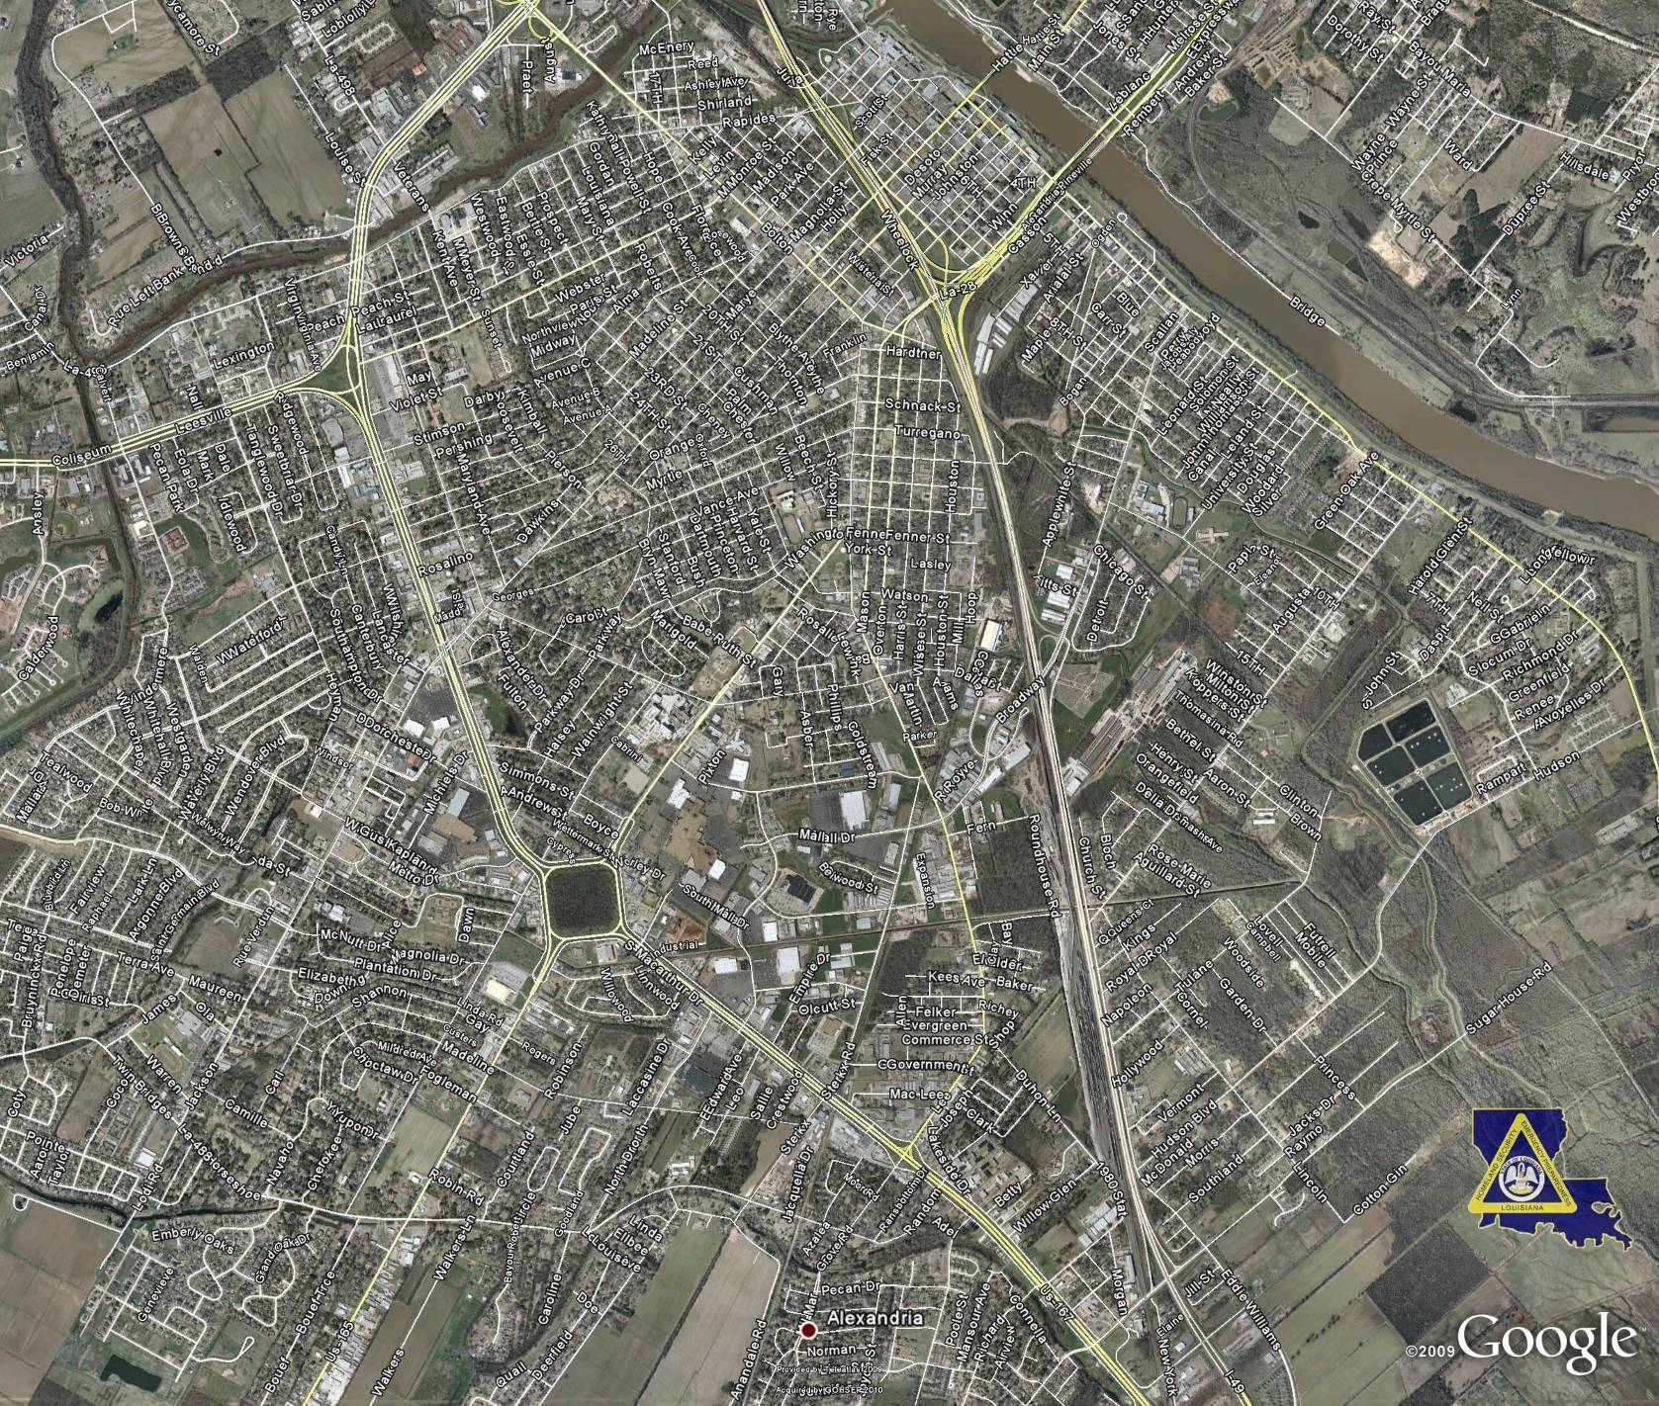
Attachment 1
Hudson Boulevard – Chatlin Lake Canal Bridge Replacement
Project Location Map


